Child’s name:_____________________________________ Class: __________

This form is to be completed for SHORT (no longer than 3 days) Leave of Absence

Reason for request: Religious day*____ *Doctors/ *Hospital appointment ________________

*Other - please specify ____________________________________________________________

If the absence is due to medical / passport renewal – evidence must be provided or the absence will be unauthorised.

Absence dates: (from) ________________________ to _____________________________

Date my child will return to school: _______________Total of school days requested:___________

Signed Parent / Carer _________________________________________ Date________________

Office Use Only:

Date Received:

Previous absences: YES /NO  Dates & reasons: |  | Which zone is your child in?  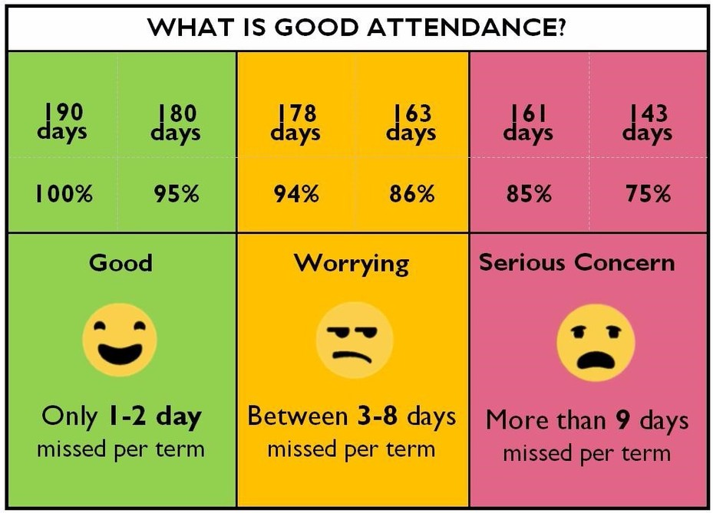  Parents and carers have the legal responsibility to ensure that a child attends school regularly and arrives on time. Absence taken during school time can have a negative impact on a child’s education.
Year Group______

%  attendance | Last academic year____  Present ______
Leave Authorised ___________________

NOT authorised ____________________

Signed: __________________________________ Date: ____________________
Miss Odedra - Headteacher

